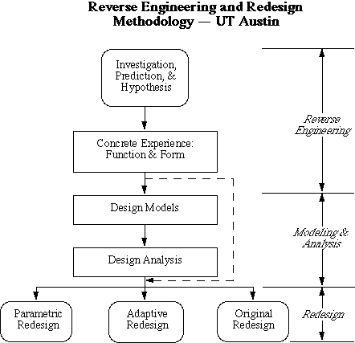
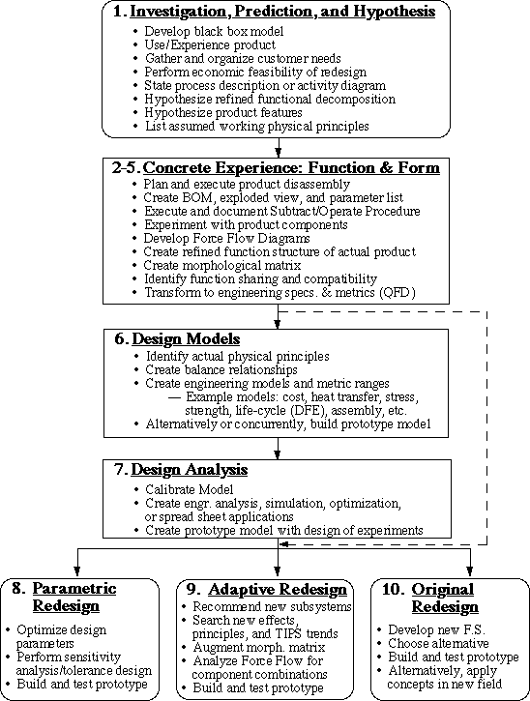
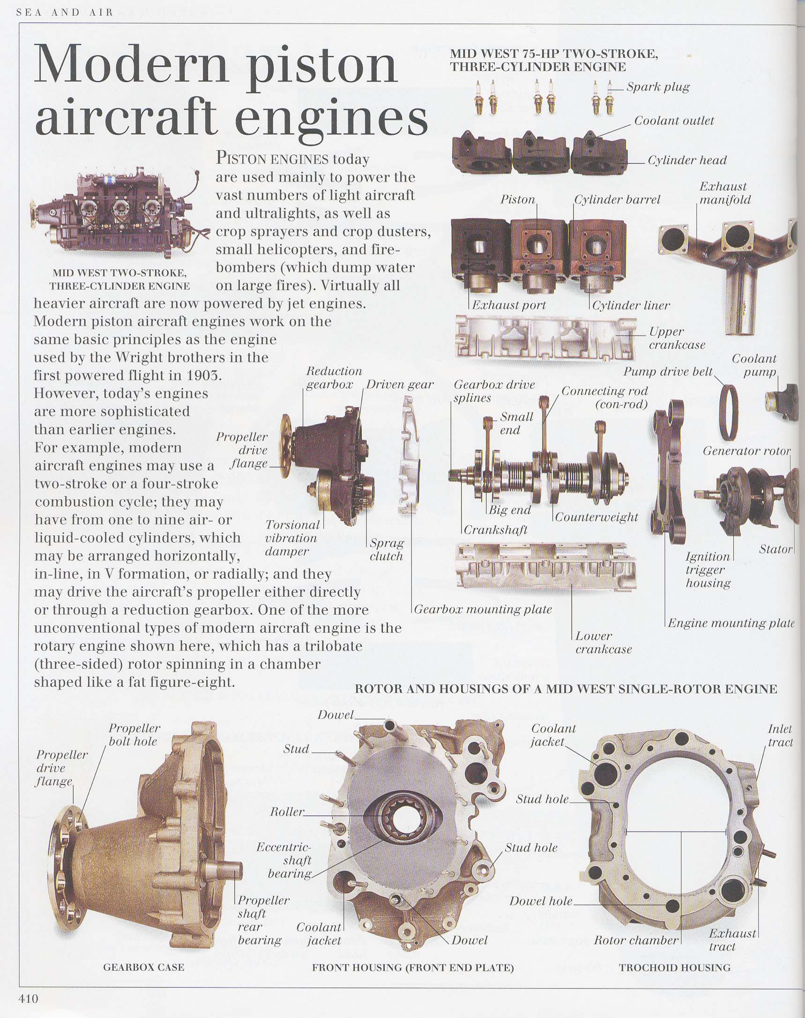
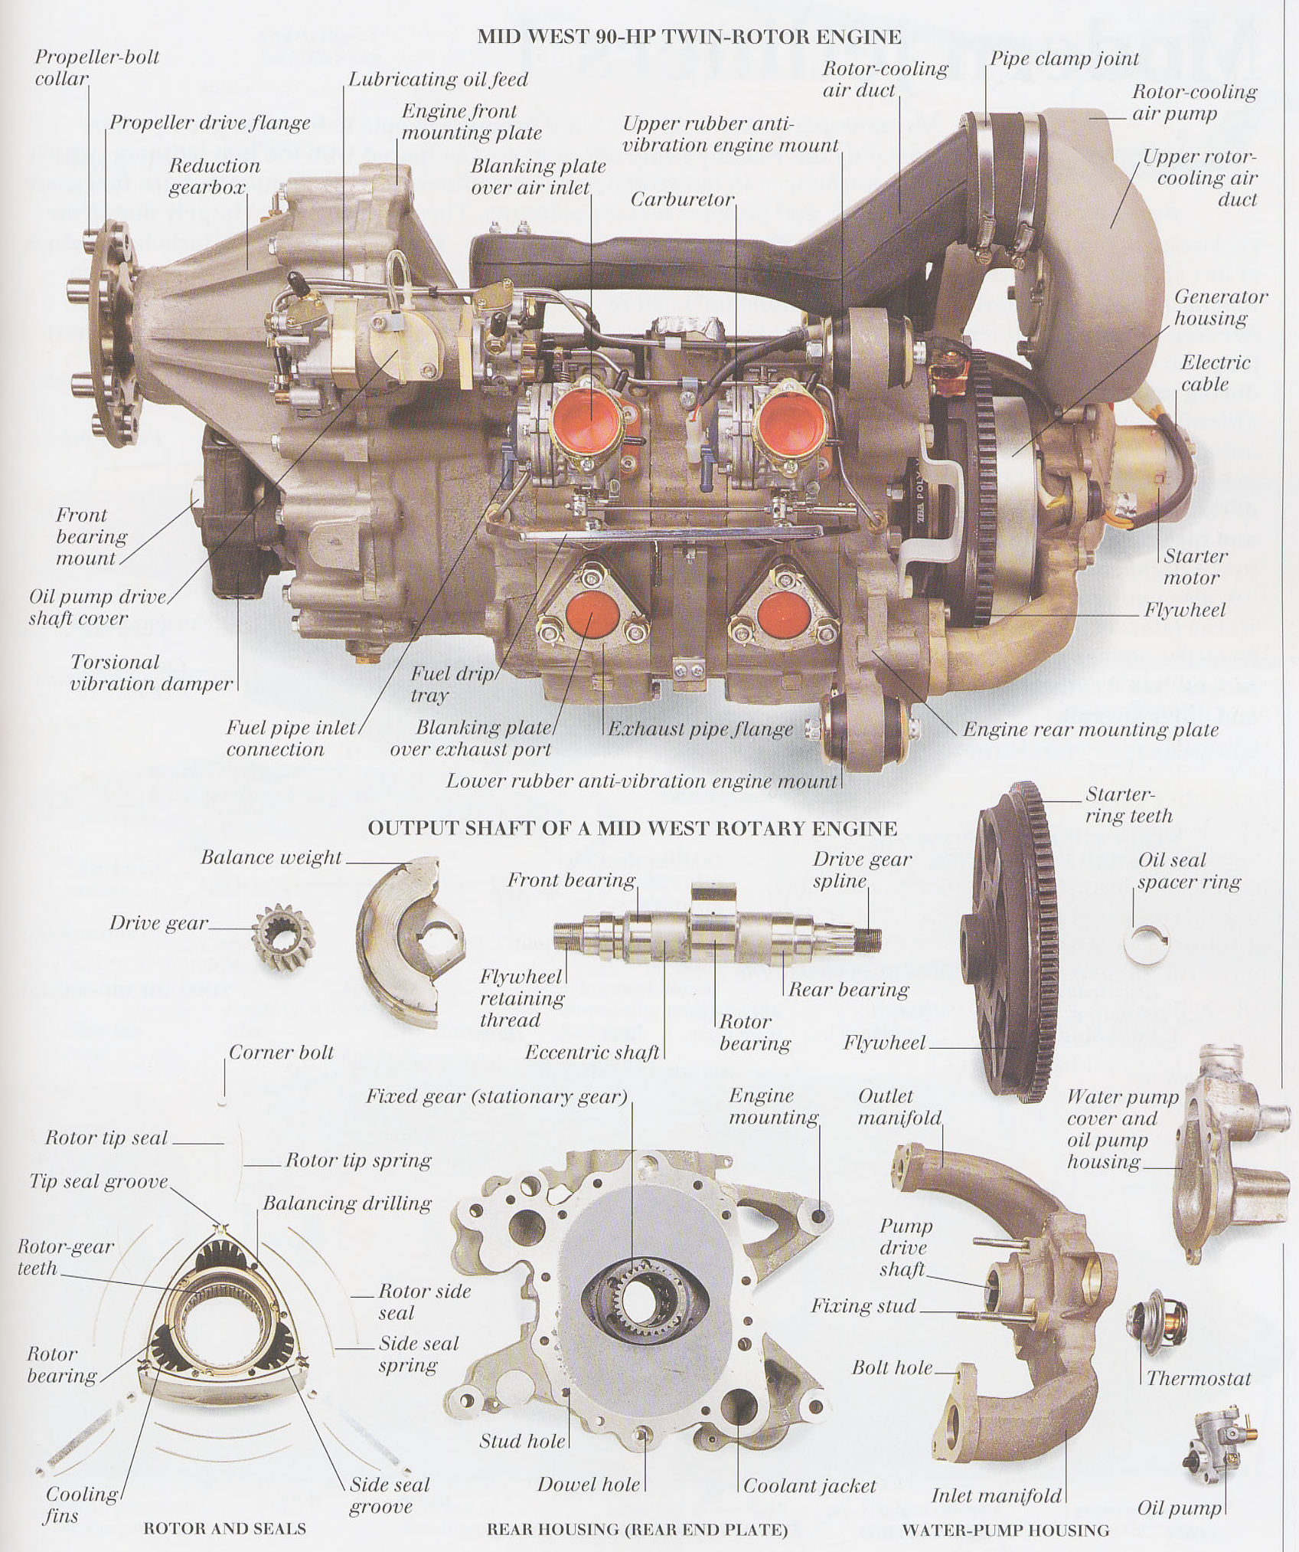

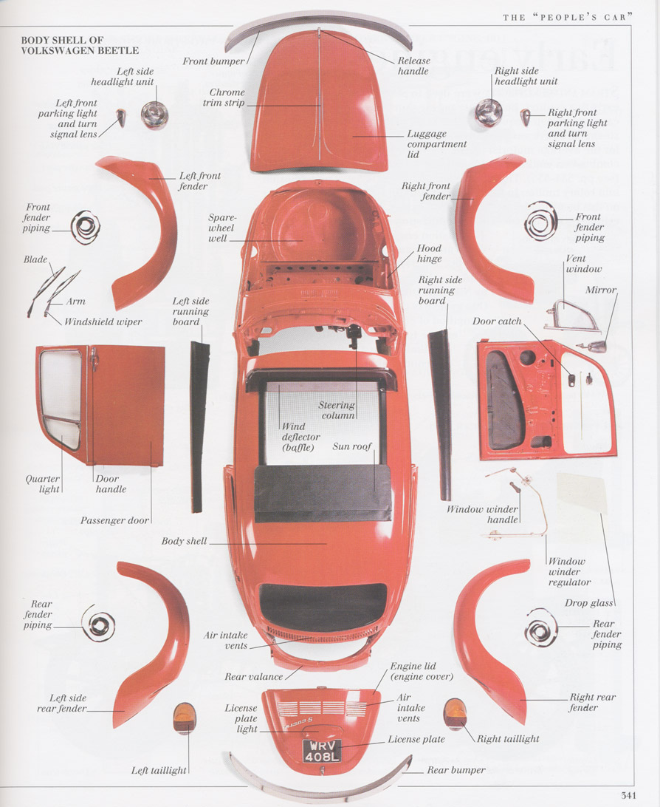

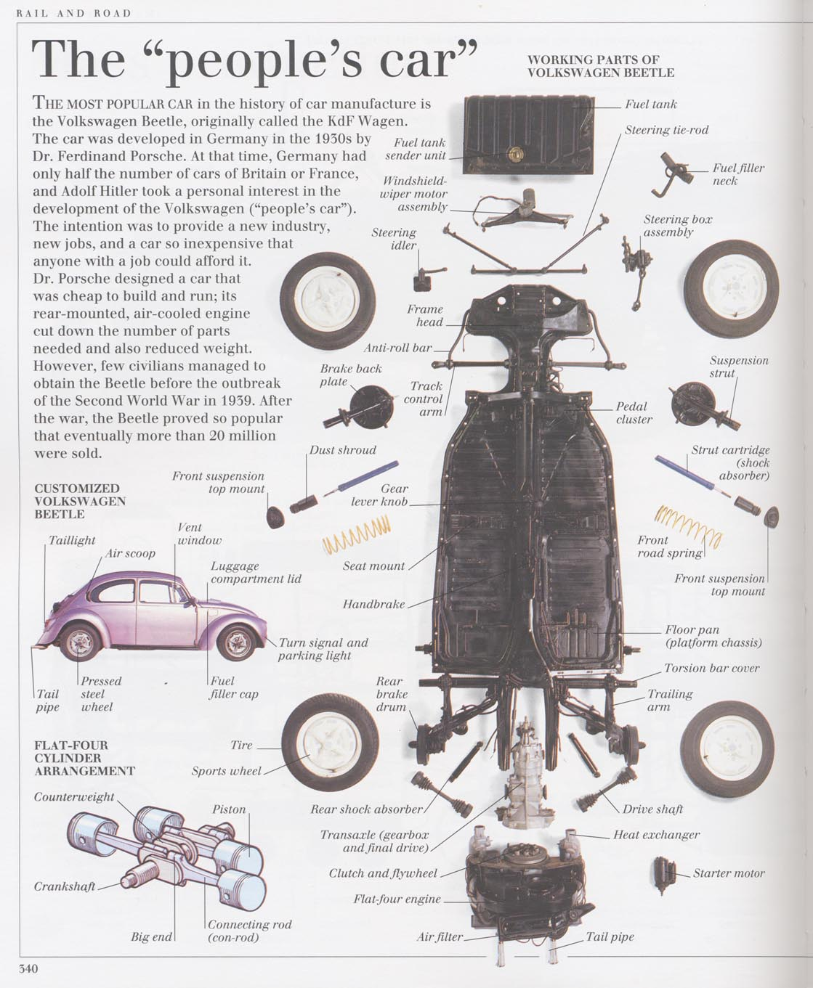

The Class Problem

Team KSA Inc is considering entering the X (e.g., can opener, mixer, etc.) market but before they do Team KSA would like your team to “reverse engineer (& redesign)” a competitor’s product. Team KSA is particularly interested in:

what parts are in the product (plan and execute product disassembly, create BOM)

how the parts are manufactured (e.g., stamping, injection molding, etc.)

the reasons why the parts are what they are (i.e., why that material, shape, color, thickness, etc.)

how the parts contribute to the device’s functioning (Subtract/Operate Procedure), and

ideas on:

how to reduce the part count

how to redesign the parts (or the manufacturing of the parts) to make the device cheaper, stronger, faster, better!

Step One

Construct and WRITE DOWN your goals and your plan for reverse engineering your device

Examine your device to see how it works and, if you have not already done so, plan how you will dissect it (and put it back together)

Once you have completed your plan, begin to dissect the device (if not already dissected).

Step Two

Choose which part(s) you are going to focus on.

Analyze the materials used to construct the part(s).

Determine the function of the part(s). Think about how the product would operate if the part were removed.

Write down reasons for why the part(s) are what they are; think about what potential problems were solved by making the parts the way they are (i.e., why that material, shape, color, thickness, etc.).

Write down whatever you know or can deduce about how the part(s) are manufactured.

Step Three

Write down how you would redesign the device, the part(s), and/or the manufacturing processes to:

reduce the part count

make the manufacturing process / the device / the part(s): better, faster, cheaper, stronger, easier to use

Step Four

Reflect on why the changes you have suggested have not already been done by the engineers who originally designed the device.

DO NOT WRITE ON THIS SHEET – RETURN TO TABLE ENVELOPE
Team: ____________
Device: _____________________

Goals for reverse engineering of assigned device (Problem definition?)

Plan for reverse engineering of device. Include plans for any proposed disassembly. (Implementation?)

Part(s) chosen for reverse engineering analysis: _________________________________
The function of the part(s) in the device:

Describe the part(s) (you may, if you wish, attach sketches to the back of this sheet) - material(s), shape, size color, hardness, thickness, etc.

WHY does the part(s) have these properties? What potential problems were solved by designing the part(s) to have these properties?

Write down whatever you know or can deduce about how the part(s) are manufactured.

Write down how you would re-engineer the device, the part(s), and/or the manufacturing processes to (a) reduce the part count, or (b) make the device/the parts: better, faster, cheaper, stronger, easier to use
Why are the changes suggested above not part of the device?
List at least five of the problem solving tools/heuristics/skills/approaches that you used in the course of this exercise. Describe why you chose them and how you used them.
Process Check
(team discuss, fill out and submit at Instructor’s table)

AGREE DISAGREE
The class Helped Us Understand
Reverse Engineering 1 2 3 4 5
The Team Feels Very Comfortable
working with manufactured devices 1 2 3 4 5
considering manufacturing aspects
of common devices/appliances 1 2 3 4 5
suggesting improvements to the
design/manufacture of devices 1 2 3 4 5
The team stayed focused on the tasks 1 2 3 4 5

List a change in today’s class that would enable your team to learn more effectively:

